# Lab 02b - Manage Governance via Azure Policy

Made by Valeriy Manuilyk <3

## Task 1: Assign tags via the Azure portal

1.Sign in to the ****Azure portal**** - https://portal.azure.com.

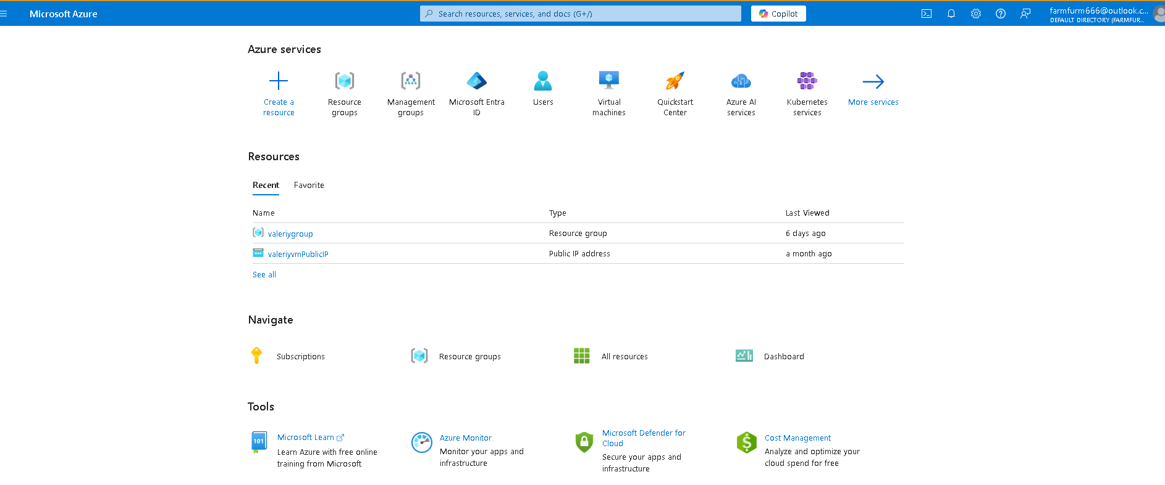

2.Search for and select Resource groups.

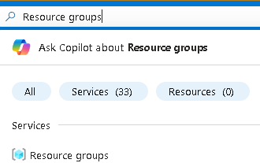

3.From the Resource groups, select ****+ Create****.

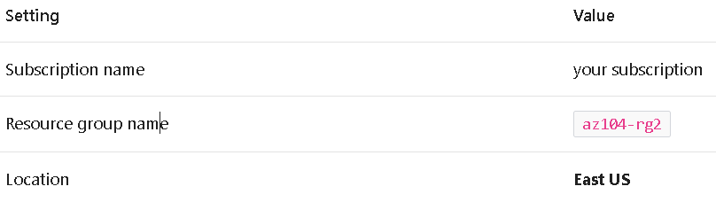

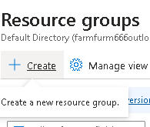

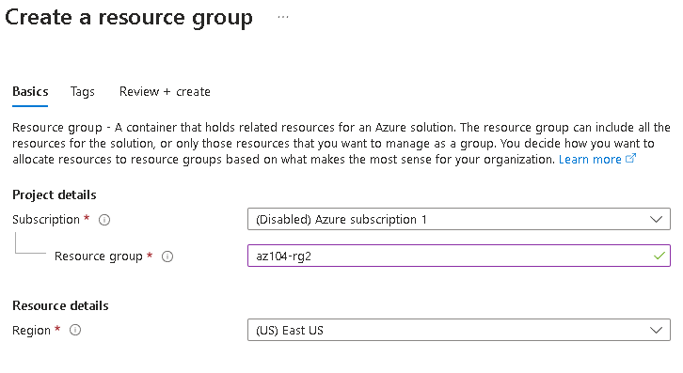

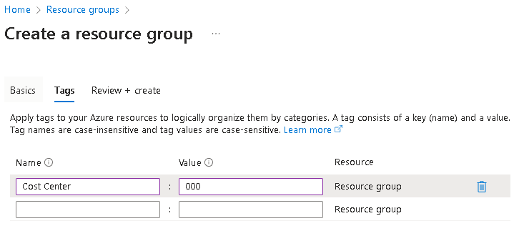

4.Select ****Next: Tags**** and create a new tag.

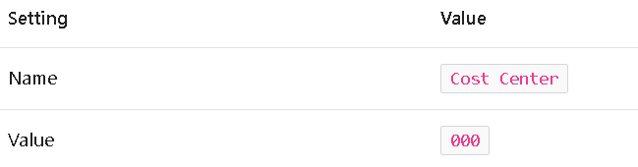

5.Select ****Review + Create****, and then select ****Create****.

## Task 2: Enforce tagging via an Azure Policy

1.In the Azure portal, search for and select Policy.

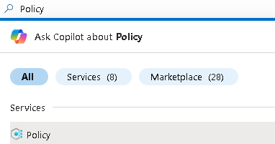

2.In the ****Authoring**** blade, select ****Definitions****. Take a moment to browse through the list of [built-in policy definitions](https://learn.microsoft.com/azure/governance/policy/samples/built-in-policies) that are available for you to use. Notice you can also search for a definition.

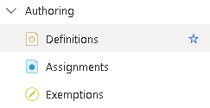

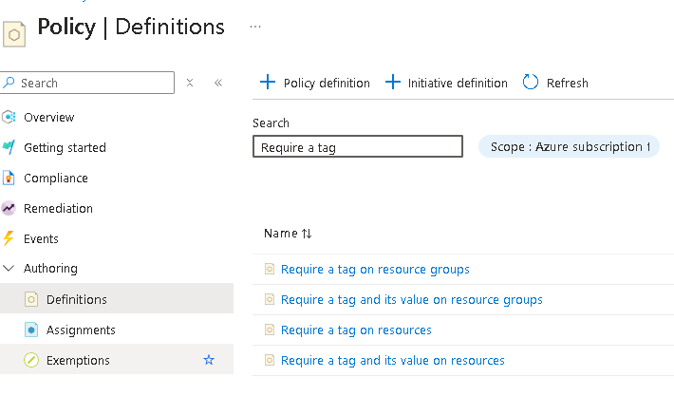

3.Click the entry representing the ****Require a tag and its value on resources**** built-in policy. Take a minute to review the definition.

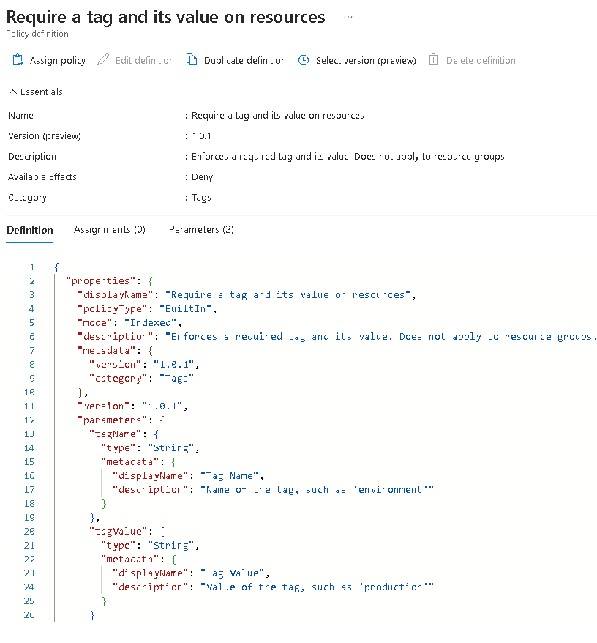

1. On the ****Require a tag and its value on resources**** built-in policy definition blade, click ****Assign****.

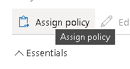

5.Specify the ****Scope**** by clicking the ellipsis button and selecting the following values. Click ****Select**** when you are done.

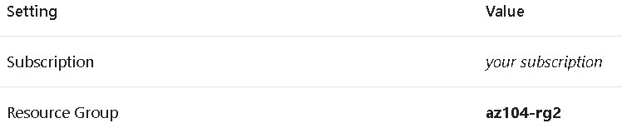

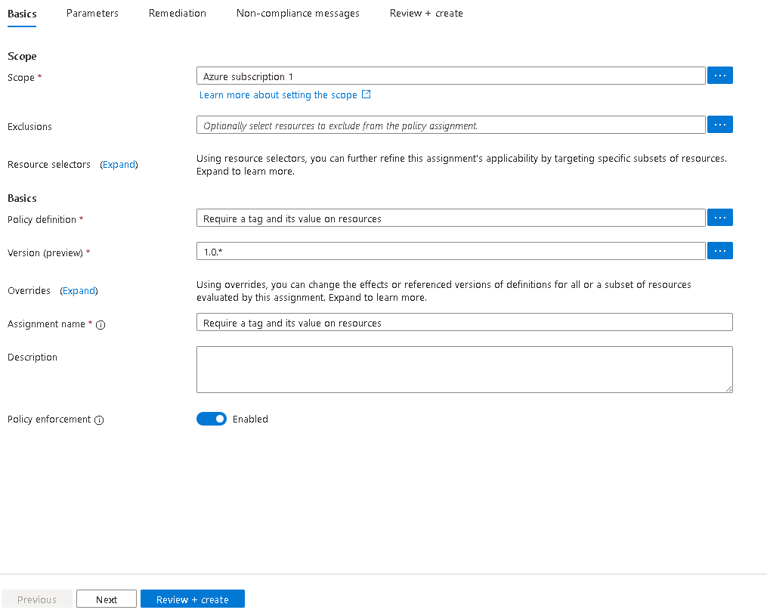

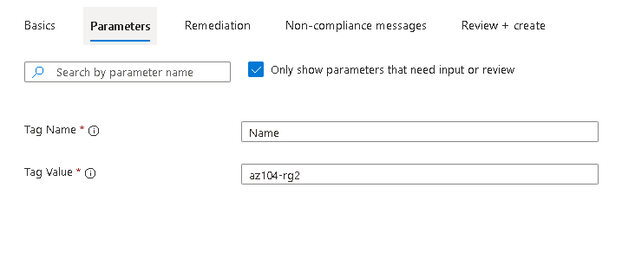

6.Configure the ****Basics**** properties of the assignment by specifying the following settings (leave others with their defaults):

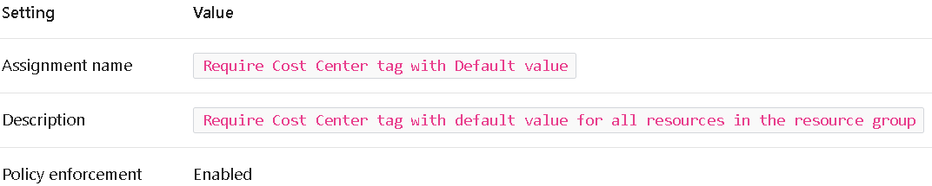

7.Click ****Next**** and set ****Parameters**** to the following values:

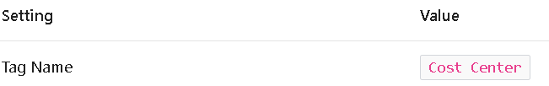

8.Click ****Next**** and, on the ****Remediation**** tab, configure the following settings (leave others with their defaults):

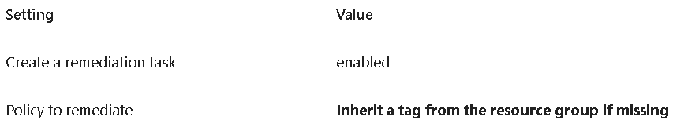

9.Click ****Review + Create**** and then click ****Create****.

10.Search for and select Storage Account, and click ****+ Create****.

11.On the ****Basics**** tab of the ****Create storage account**** blade, verify that you are using the Resource Group that the Policy was applied to and specify the following settings (leave others with their defaults) and click ****Review****:



12.Verify that this time the validation passed and click ****Create****.

13.Once the new storage account is provisioned, click ****Go to resource****.

14.On the ****Tags**** blade, note that the tag ****Cost Center**** with the value ****000**** has been automatically assigned to the resource.

## Task 4: Configure and test resource locks

1.Search for and select your resource group.

2.In the ****Settings**** blade, select ****Locks****.

3.Select ****Add**** and complete the resource lock information. When finished select ****Ok****.

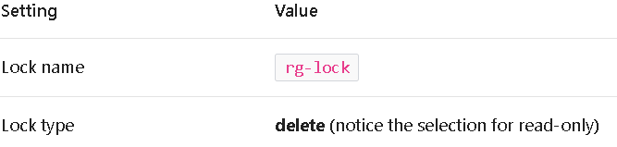

4.Navigate to the resource group ****Overview**** blade, and select ****Delete resource group****.

5.In the ****Enter resource group name to confirm deletion**** textbox provide the resource group name, az104-rg2. Notice you can copy and paste the resource group name.

6.Notice the warning: Deleting this resource group and its dependent resources is a permanent action and cannot be undone. Select ****Delete****.

7.You should receive a notification denying the deletion.